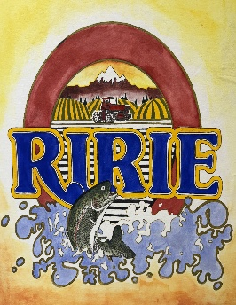
Business License Application
The City of Ririe
P.O. Box 68
464 Main St,
Ririe, ID 83443
208-538-5548

Application Date: ___________________
FEES:
General Business License…………………………………………………………$25.00 1st year.
Effective January 1, 2026. (Free renewal with updated application yearly.)
Late Fee after January 31 2026.
Door to Door Sales Solicitor's Permit per salesman……………….,…$25.00 for 120 days.
Short Term Business (mobile food)…………………………………………...$25.00 for 30 days
Failure to get Business License………………………………………………….$10.00 fine

BUSINESS INFORMATION (Please Print)
Name: Located at (Address): City State Zip Phone #: Business Email: Idaho Sales Tax #: State License #: Anticipated number of employees including self:
Mailing Address: ____________________________________

OWNER
Name: Date of Birth: / / Home Address: City State Zip Personal Phone #: Work Phone #: Driver’s License #: State: Previous Address: City State Zip
(If less than 2 years)

MANAGER AND/OR KEHOLDER FOR EMERGENCIES (If different from owner)
Name: Date of Birth: / / Home Address: City State Zip Personal Phone #: Work Phone #: Driver’s License #: State: Previous Address: City State DETAILED BUSINESS DESCRIPTION (Please describe business and operation):

